## Install the Balabit certificate & update host table (required for RDP

## access)

If you just need to access Linux, Solaris or AIX machines or WinSCP only, you may skip this part as it is only required for RDP access to windows server access in SCB GWAN via RD Gateway.

Under Internet Options🡪Click Content and then 🡪 Click Certificates

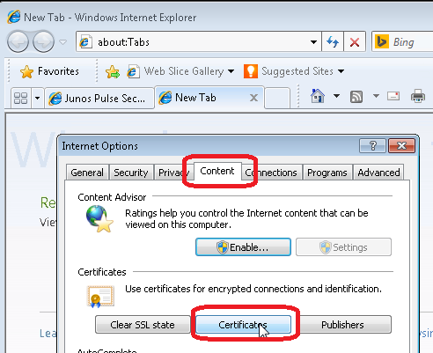

Under Trusted Root Certification Authorities 🡪Click Import to import the certificate

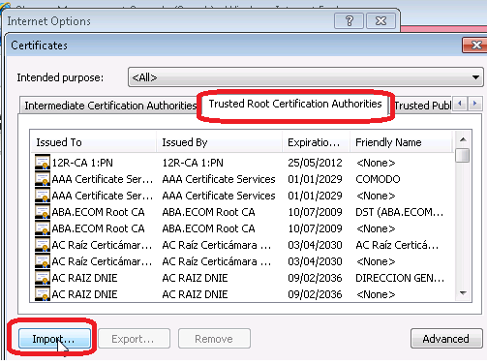

If you just need to access Linux, Solaris or AIX machines or WinSCP only, you may skip this part as it is only required for RDP access to windows server access in SCB GWAN via RD Gateway.

Browse and select the Balabit certificate (GISCA02.cer) and click <Next>

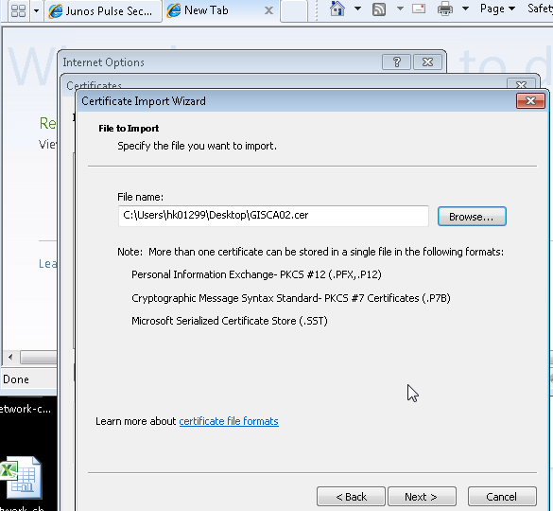

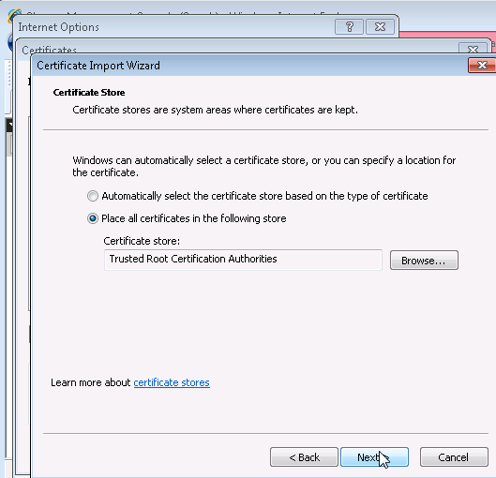

If you just need to access Linux, Solaris or AIX machines or WinSCP only, you may skip this part as it is only required for RDP access to windows server access in SCB GWAN via RD Gateway.

And the certificate “Standard Chartered Bank GISCA02” is imported.

